The comparison of associating liver partition and portal vein ligation for staged hepatectomy versus portal vein embolization in postoperative outcomes and complications for the treatment of liver cancer with insufficient future liver remnant: a Meta analysis and systematic review

Additional file
Appendix file 1 the Preferred Reporting Items for Systematic Reviews and Meta-Analyses (PRISMA) 2009 Checklist.
Appendix file 2 the Risk of bias in the included retrospective cohort studies (by the Newcastle–Ottawa quality assessment tool).
Appendix file 4 A flow diagram of the inclusion criteria of studies.
Appendix file 5 the forest plot of OR of the second stage hepatectomy.
Appendix file 6 the forest plot of MD of the sufficient FLR growth.
Appendix file 7 the forest plot of MD of the time to stage II operation.
Appendix file 8 the forest plot of OR of the rate of R0 resection.
Appendix file 9 the forest plot of OR of the mortality within 90 days of perioperative period.
Appendix file 10 the forest plot of OR of the Overall postoperative complication rate.
Appendix file 11 the forest plot of OR of the incidence of postoperative liver failure.
Appendix file 12 the forest plot of OR of MD of the postoperative hospital stay.
Appendix file 13 the publication funnel plot of included literature.
Additional file 14: Search strategy.

Appendix 1 the Preferred Reporting Items for Systematic Reviews and Meta-Analyses (PRISMA) 2009 Checklist


PRISMA 2009 Checklist
Section/topic | # | Checklist item | Reported on page #
TITLE
Title | 1 | Identify the report as a systematic review, meta-analysis, or both. | 1
ABSTRACT
Structured summary | 2 | Provide a structured summary including, as applicable: background; objectives; data sources; study eligibility criteria, participants, and interventions; study appraisal and synthesis methods; results; limitations; conclusions and implications of key findings; systematic review registration number. | 1
INTRODUCTION
Rationale | 3 | Describe the rationale for the review in the context of what is already known. | 2
Objectives | 4 | Provide an explicit statement of questions being addressed with reference to participants, interventions, comparisons, outcomes, and study design (PICOS). | 2
METHODS
Protocol and registration | 5 | Indicate if a review protocol exists, if and where it can be accessed (e.g., Web address), and, if available, provide registration information including registration number. | 3
Eligibility criteria | 6 | Specify study characteristics (e.g., PICOS, length of follow-up) and report characteristics (e.g., years considered, language, publication status) used as criteria for eligibility, giving rationale. | 3
Information sources | 7 | Describe all information sources (e.g., databases with dates of coverage, contact with study authors to identify additional studies) in the search and date last searched. | 3
Search | 8 | Present full electronic search strategy for at least one database, including any limits used, such that it could be repeated. | 3
Study selection | 9 | State the process for selecting studies (i.e., screening, eligibility, included in systematic review, and, if applicable, included in the meta-analysis). | 3
Data collection process | 10 | Describe method of data extraction from reports (e.g., piloted forms, independently, in duplicate) and any processes for obtaining and confirming data from investigators. | 4
Data items | 11 | List and define all variables for which data were sought (e.g., PICOS, funding sources) and any assumptions and simplifications made. | 4
Risk of bias in individual studies | 12 | Describe methods used for assessing risk of bias of individual studies (including specification of whether this was done at the study or outcome level), and how this information is to be used in any data synthesis. | 4
Summary measures | 13 | State the principal summary measures (e.g., risk ratio, difference in means). | 4
Synthesis of results | 14 | Describe the methods of handling data and combining results of studies, if done, including measures of consistency (e.g., I²) for each meta-analysis. | 4

Page 1 of 2
Section/topic | # | Checklist item | Reported on page #
Risk of bias across studies | 15 | Specify any assessment of risk of bias that may affect the cumulative evidence (e.g., publication bias, selective reporting within studies). | 4
Additional analyses | 16 | Describe methods of additional analyses (e.g., sensitivity or subgroup analyses, meta-regression), if done, indicating which were pre-specified. | 4
RESULTS
Study selection | 17 | Give numbers of studies screened, assessed for eligibility, and included in the review, with reasons for exclusions at each stage, ideally with a flow diagram. | 5,Fig1
Study characteristics | 18 | For each study, present characteristics for which data were extracted (e.g., study size, PICOS, follow-up period) and provide the citations. | 5, Table 1
Risk of bias within studies | 19 | Present data on risk of bias of each study and, if available, any outcome level assessment (see item 12). | 5-7
Results of individual studies | 20 | For all outcomes considered (benefits or harms), present, for each study: (a) simple summary data for each intervention group (b) effect estimates and confidence intervals, ideally with a forest plot. | 5-7
Synthesis of results | 21 | Present results of each meta-analysis done, including confidence intervals and measures of consistency. | 5-7
Risk of bias across studies | 22 | Present results of any assessment of risk of bias across studies (see Item 15). | 5-7
Additional analysis | 23 | Give results of additional analyses, if done (e.g., sensitivity or subgroup analyses, meta-regression [see Item 16]). | 5-7
DISCUSSION
Summary of evidence | 24 | Summarize the main findings including the strength of evidence for each main outcome; consider their relevance to key groups (e.g., healthcare providers, users, and policy makers). | 7
Limitations | 25 | Discuss limitations at study and outcome level (e.g., risk of bias), and at review-level (e.g., incomplete retrieval of identified research, reporting bias). | 11
Conclusions | 26 | Provide a general interpretation of the results in the context of other evidence, and implications for future research. | 11
FUNDING
Funding | 27 | Describe sources of funding for the systematic review and other support (e.g., supply of data); role of funders for the systematic review. | No funder
From: Moher D, Liberati A, Tetzlaff J, Altman DG, The PRISMA Group (2009). Preferred Reporting Items for Systematic Reviews and Meta-Analyses: The PRISMA Statement. PLoS Med 6(7): e1000097. doi:10.1371/journal.pmed1000097
For more information, visit: www.prisma-statement.org.

Appendix 2 Risk of bias in the included retrospective cohort studies (by the Newcastle–Ottawa quality assessment tool)
Supplemental NOS for Cohort Studies
 | Representativeness of the exposed cohort | Selection of the non-exposed cohort | Ascertainment of exposure | Demonstration that outcome of interest was not present at start of study | Comparability of cohorts on the basis of the design or analysis^{b} | Assessment of outcome | Was follow-up long enough for outcome to occur | Adequacy of follow-up of cohorts | Total quality scores
Adam R (2016) | * | * | * | * | ** | * | * | * | 9
Chan A (2019) | * | - | * | * | * | * | * | * | 7
Chia DKA (2018) | * | * | * | * | ** | * | * | * | 9
Junichi Shindoh (2013) | * | - | * | * | * | * | - | * | 6
Knoefel W.T (2013) | * | * | - | * | * | * | * | * | 7
Croome (2015) | * | * | - | * | * | * | * | * | 7
Matsuo K (2016) | * | * | - | * | ** | * | * | * | 8
Ratti F (2015) | * | * | * | * | ** | * | * | * | 9
Sandström P (2018) | * | * | * | * | ** | * | * | * | 9
Schadde E (2014) | * | - | * | * | * | * | - | * | 6
Tanaka K (2015) | * | * | - | * | ** | * | * | * | 8
a A study can be awarded a maximum of one star for each numbered item except for the item Control for important factor or additional factor.
b A maximum of two stars can be awarded for Control for important factor or additional factor.
Newcastle Ottawa scale (NOS) to assess the methodological quality of case-control and cohort studies. The NOS scale included three evaluation criteria: patient selection (four stars), comparability (two stars) of the study group and outcome evaluation (three stars).

Appendix file 4 A flow diagram of the inclusion criteria of studies.
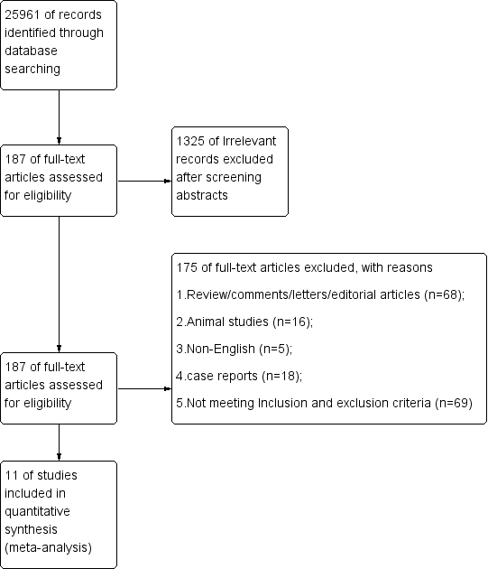

Appendix file 5 the forest plot of OR of the second stage hepatectomy
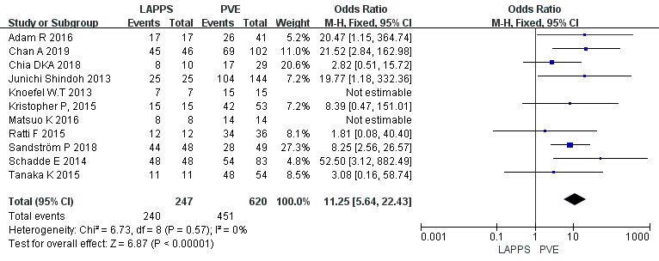

Appendix file 6 the forest plot of MD of the sufficient FLR growth.
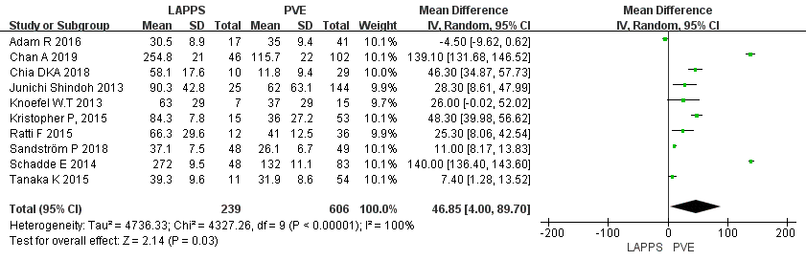

Appendix file 7 the forest plot of MD of the time to stage II operation
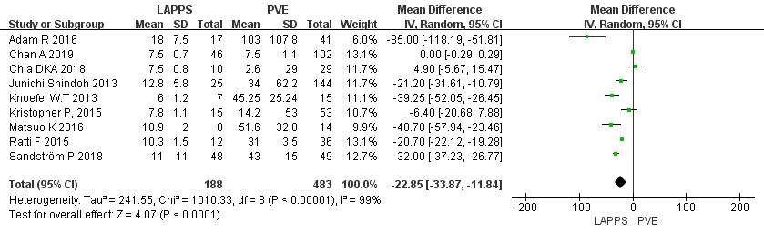

Appendix file 8 the forest plot of OR of the rate of R0 resection
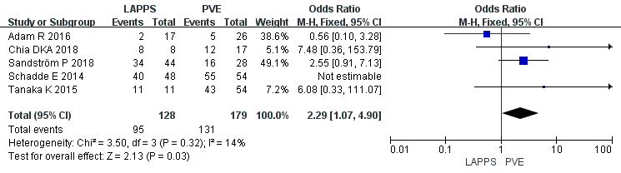

Appendix file 9 the forest plot of OR of the mortality within 90 days of perioperative period
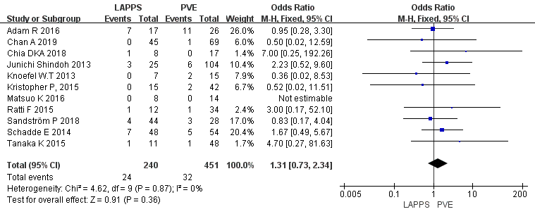

Appendix file 10 the forest plot of OR of the Overall postoperative complication rate
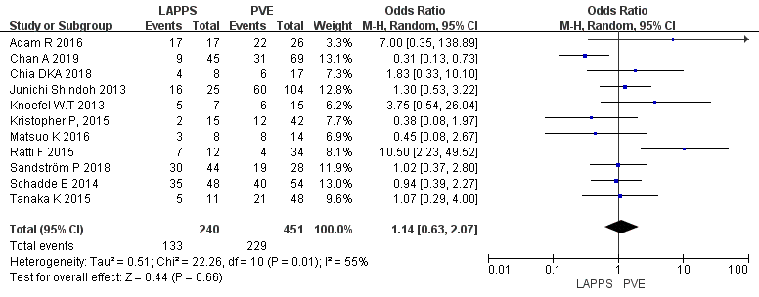

Appendix file 11 the forest plot of OR of the incidence of postoperative liver failure
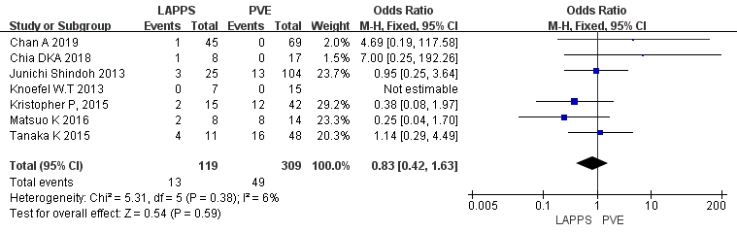

Appendix file 12 the forest plot of OR of MD of the postoperative hospital stay
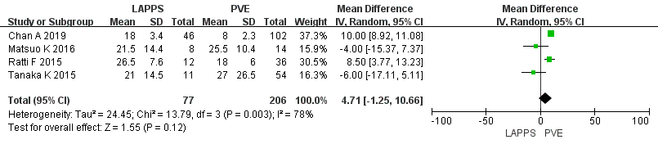

Appendix file 13 the publication funnel plot of included literature
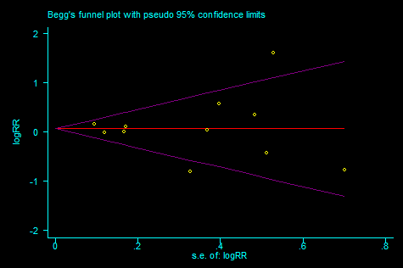

Additional file 14: Search strategy
We conducted a comprehensive systematic literature search of online database in PubMed database from January 2010 to January 2020 to identify all of RCTs and observational studies. Eligible trials were independently selected by two reviewers. Differences observed between the two reviewers were resolved through discussions with a third reviewer. Inclusion criteria were: (1) the included literature should contain the abstract and full text of the published literature from January 2010 to January2020; (2) literature design type: Cohort studies, case-control studies, and randomized controlled studies with strict inclusion and exclusion criteria(7); (3) The number of cases in the literature was ≥5, and the subjects were FLR-deficient patients with intermediate or advanced liver cancer, including primary or metastatic tumor cases, without restrictions of radiotherapy and chemotherapy; (4) Major indicators such as FLR growth rate and two-step surgical completion rate have been recorded in the literature. Exclusion criteria were：(1) the type of literature design is not clear, and the general situation of the included patients is not clear; (2) the included study language is limited to English; (3) data duplication; (4) the grouping description in the included literature is not clear, and some items are missing.

MEDLINE is the premier biomedical bibliographic database, produced by the National Library of Medicine (NLM). NLM indexes over 4600 worldwide life science journals. MEDLINE includes over 12 million references from 1966 to the present. Indexers assign Medical Subject Headings (MeSHs), NLM’s controlled thesaurus of descriptors. Most of the references starting in 1975 also contain an abstract. MEDLINE was searched using the PubMed search interface.
The following search strategy was used:
#1 ((((((((((((((associating liver partition and portal vein ligation for staged hepatectomy)) OR ALPPS) AND portal vein embolization) OR PVE) OR portal vein ligation) OR PVI) OR portal vein occlusion) OR PVO)
#2 hepatectomy) OR staged hepatectomy) OR staged liver resection) OR liver resection) OR two-stage hepatectomy) OR hepatic resection
#3 #1AND#2

Despite having searched only one database, we included an extensive number of studies, and the flowchart of trials is presented in Figure 1.

